Resultaten

# Strategie 7

Soft 17 : Dealer hits

Doubles : Double any 2 cards

Double after split : allowed

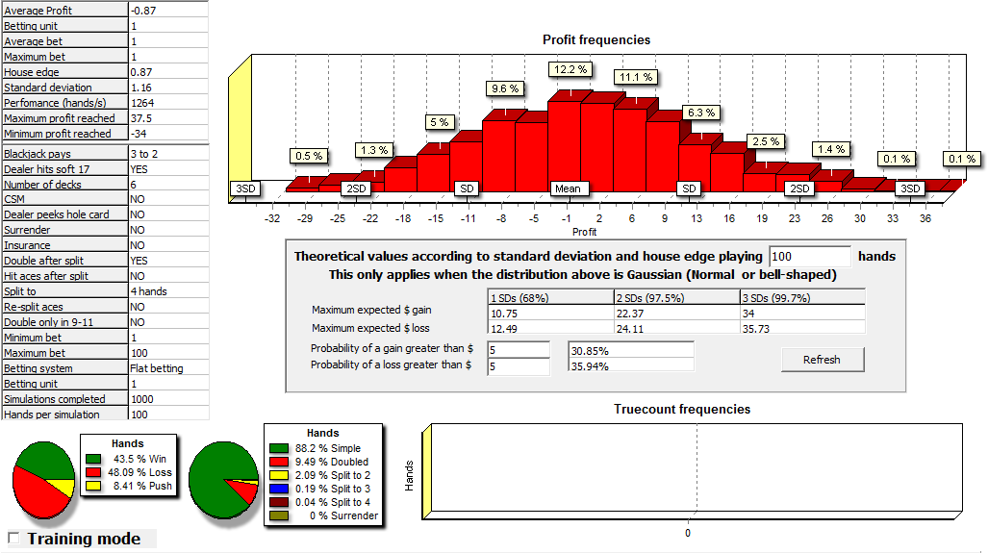

# Strategie 8

Soft 17 : Dealer hits

Doubles : Double any 2 cards

Double after split : not allowed

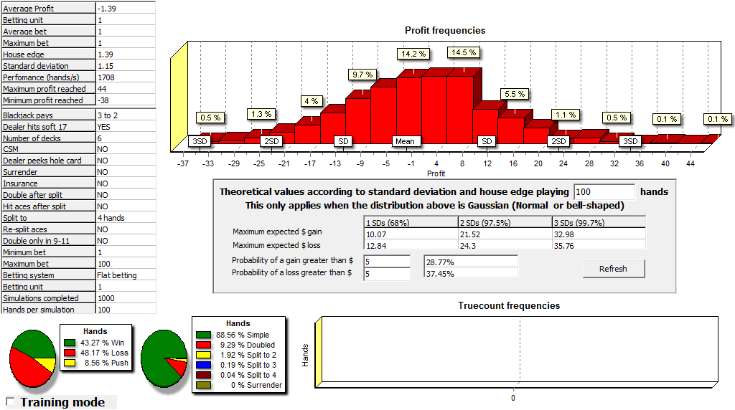

# Strategie 9

Soft 17 : Dealer hits

Doubles : Double 9,10,11 only

Double after split : allowed

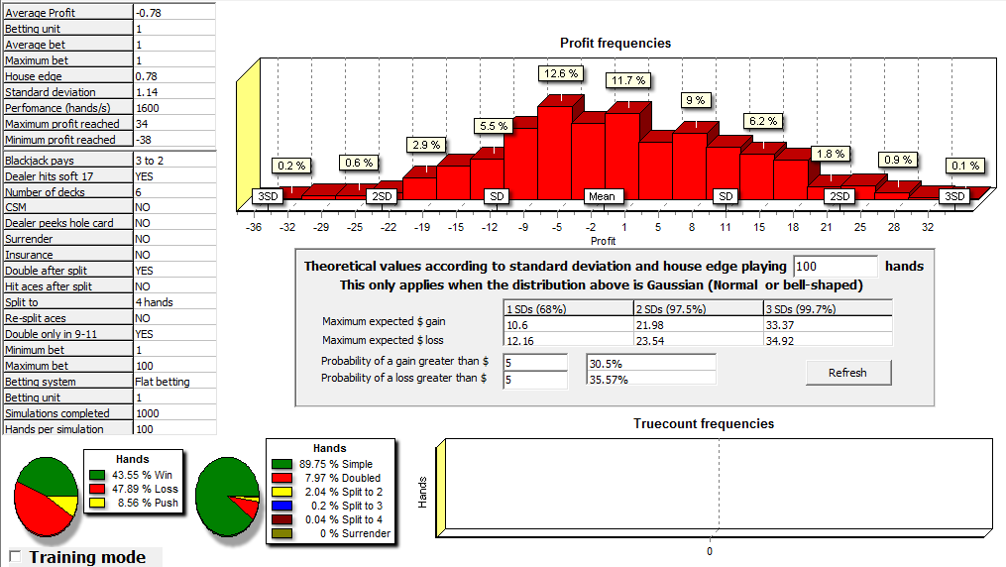

# Strategie 10

Soft 17 : Dealer hits

Doubles : Double 9,10,11 only

Double after split : not allowed

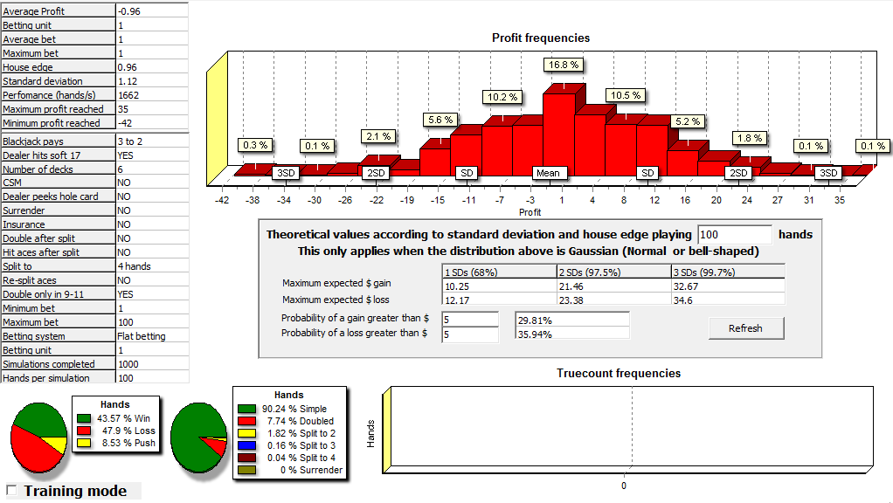

# Strategie 11

Soft 17 : Dealer hits

Doubles : Double any 2 cards

Double after split : allowed

Surrender : late surrender

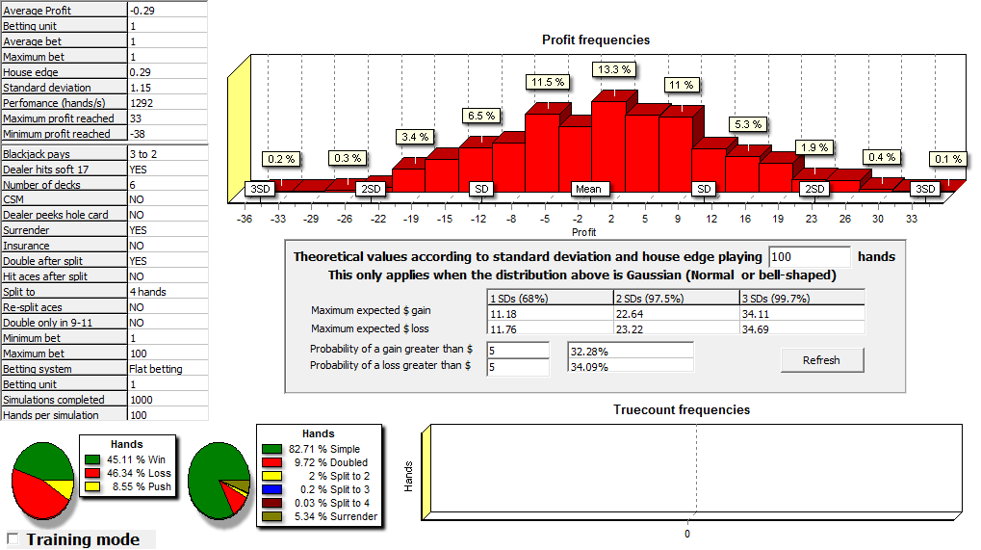

# Strategie 11

Soft 17 : Dealer hits

Doubles : Double 9,10,11 only

Double after split : allowed

Surrender : late surrender

